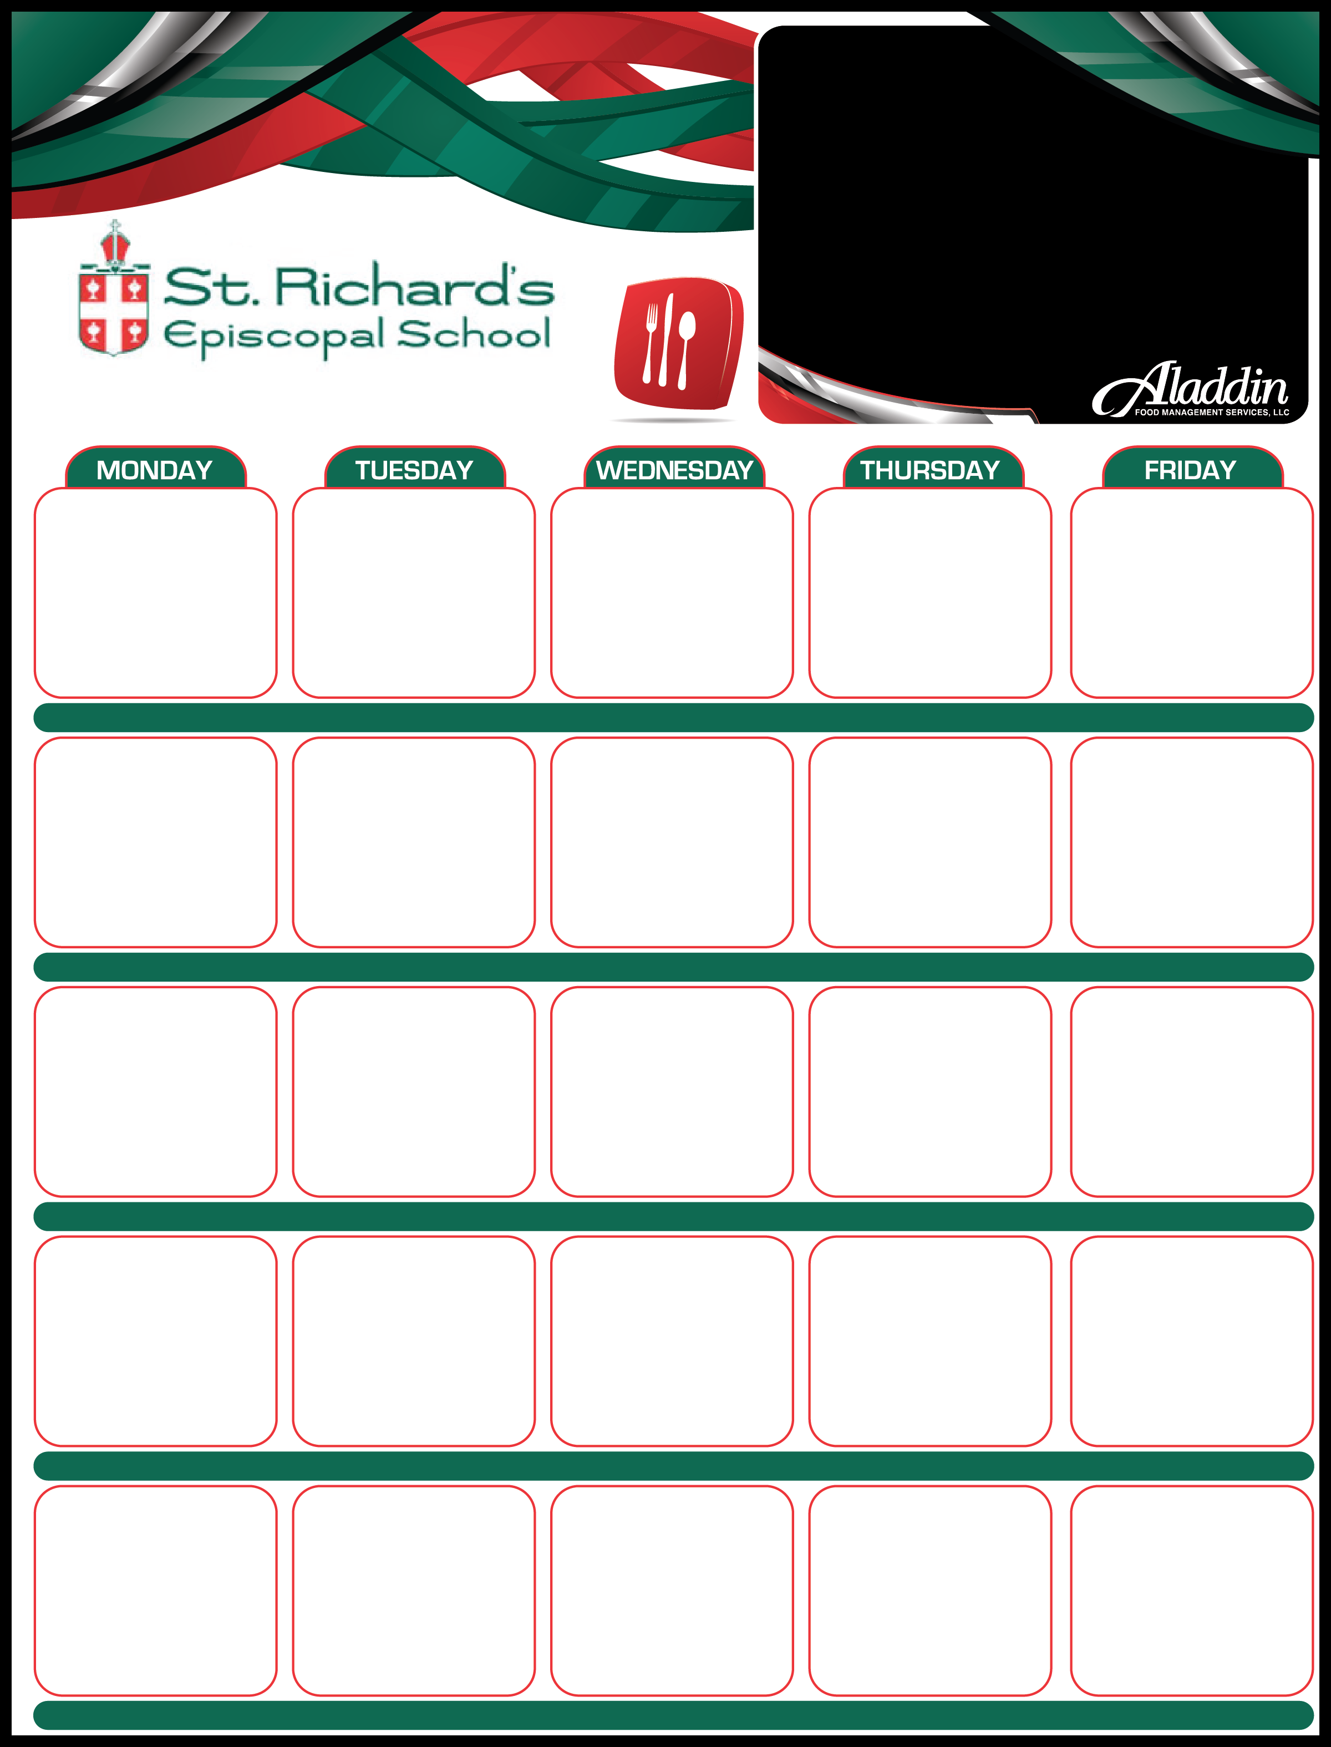

Summer Break

May 16

Pulled Pork

Mac & Cheese*

Broccoli*

Watermelon*

Veggie Crumbles*

***Offered Daily***

**Sandwich Options:**

**Ham & Cheese**

**Turkey & Cheese**

**Ham Only**

**Turkey Only**

**Cheese Only**

**Sunbutter & Jelly**

**Sunbutter Only**

**Fresh Fruit, Vegetables, and Salads**

**1% Milk**

**\*Indicates Vegetarian Option**

Lunch Menu • May 2022

*

May 30

May 31

May 23

General Tso’s Chicken

White Rice*

Broccoli*

Mandarin Oranges*

General Tso’s Tofu*

May 24

Hamburgers

French Fries*

Brussels Sprouts*

Grapes*

Veggie Burgers*

May 25

Beef Tacos

Mexican Rice*

Black Bean & Corn Salsa*

Pineapple*

Veggie Tacos*

May 26

Hot Dogs

Potato Chips*

Carrots*

Watermelon*

Veggie Dogs*

May 27

May 17

Chicken Tenders

French Fries*

Brussels Sprouts*

Grapes*

Tofu Tenders*

May 18

BBQ Meatballs

Garlic Bread*

Peas & Carrots*

Pineapple*

Veggie BBQ Meatballs*

May 19

Texas Straw Hats

Black Bean & Corn Salsa*

Zucchini & Squash*

Tropical Fruit*

Veggie Straw Hats*

May 20

Spaghetti & Meat Sauce

Breadsticks*

Asparagus*

Pears*

Spaghetti Marinara*

May 13

French Toast*

Scrambled Eggs*

Turkey Sausage Links

Roast Potatoes*

Orange Wedges*

Veggie Sausage*

May 12

Grilled Cheese*

Tomato Soup*

Cauliflower*

Grapes*

May 11

Chicken Patty Sandwich

Kale Salad*

Roast Carrots*

Grapes*

Tofu Patty Sandwich*

May 10

Beef and Ricotta Ravioli

Asparagus*

Pineapple*

Cauliflower Ravioli*

May 9

Chicken & Rice

Brussels Sprouts*

Orange Wedges*

Veggies & Rice*

May 6

Fish &

Chips*

Coleslaw*

Watermelon*

Roast Portabella*

May 4

Cheese Pizza*

Kale Salad*

Roast Carrots*

Grapes*

May 5

Pork Potstickers

Veggie Fried Rice*

Broccoli*

Mandarin Oranges*

Roast Tofu*

May 3

BBQ Pork Sandwiches

Green Beans*

Tater Tots*

Pineapple*

Veggie BBQ Sandwich*

May 2

Beef Stroganoff

Peas*

Pears*

Mushroom Stroganoff*